Douro Centennial 1825 by Mrs. D. Amos
It was inevitable that Douro, which with Ennismore is the most Irish of the townships around Peterborough, should be the only one with sufficient initiative to organize a Centennial celebration, 100 years after the Robinson settlement; even the proud city of Peterborough practically ignored the centenary of its founding. Patrick G. Towns was the prime mover in having the Douro Old Boys and Girls Reunion Week, June 21 to 27, 1925, and wrote a series of memorable articles in the Peterborough Examiner to explain the background of the event. Many hundreds of old boys and girls from all parts of North America returned to visit the township where they and their parents were born.

Of great interest to all who attended was an exhibition of pioneer relics, costumes, furniture and equipment used by the first township settlers, as a contrast with the latest machinery, implements and vehicles in use in 1925. Some highlights of the program included baseball and football between neighbouring teams, running, jumping and tug-of-war contests, and team-drawing contests. An exhibition by Indians in war-dress was particularly colourful. Each school section secured the services of their oldest surviving teacher, who again taught groups of her former pupils. Public speaking and debates created interest; also an old boys and girls popularity contest. Entertainment of varied types was provided each night as a climax to each day’s activities. This was more than a social gathering. It was an opportunity for all to appreciate the debt of gratitude they owed to the hardy’ pioneers who braved great difficulties and dangers to turn a forest wilderness into a prosperous and progressive township. Friends relatives separated for many years met once more on Douro soil to share happy memories of youth and to pay and to pay tribute to their fore-fathers.

Article copied from Through the Years in Douro, 1822-1957 Chapter 22 pg 194.

Some Histoical Events of the Peterborough Canadian Irish Club
By Shirley Flemming-O’Grady
Cairde 2020

It is hard to believe that this is year, 2020. The Peterborough Canadian Irish Club is celebrating a birthday of 45 years. So many events have taken place during that time!
New members have asked about our early years and how we came to be. So much emphasis has been on 1975 when the Peterborough area celebrated the 150 years since the Robinson Emigration of 1825. The Chamber of Commerce put together a Steering Committee consisting of descendants of that group and other business persons. Many events were planned to celebrate the occasion.

Several stand out vividly in my memory such as the replica Robinson Boat and the Settler’s Monument at the foot of Charlotte Street.The builder of the Robinson Boat was Nick West and he followed the design made by Peter Robinson. Several crossings across Little Lake took place with groups of “Settlers” representing their community and they were all greeted by enthusiastic welcoming crowds as they landed at what is now a marina.

Many have asked what happened to the boat and that is a sad tale for sure. Mrs. McKelvie from Lang Pioneer Village requested the boat become the property of the Village and promised it would be covered and looked after. The last time that I went to look at it, I could hardly find the outline of it because of the vegetation and neglect. It was located behind the Douro school house.

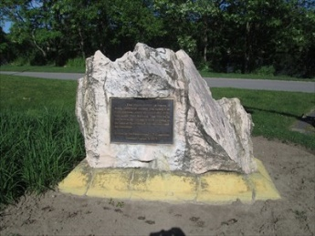
So often the Settler’s Monument at the foot of Charlottes Street is referred to as the Robinson Memorial but, in fact, it was erected in honour of the nearly 2000 Irish settlers who sailed from Cork Harbour under the leadership of Honourable Peter Robinson.

Fred O’Grady met Bill and Mary Houston of the Madoc area. They decided that because of pride of their own Irish History, they would donate marble from their quarry. After a blasting the following week, the piece selected was brought to Peterborough. The site was chosen across from the then Red Oak Inn by the late Jim Hooper, the City Engineer. The footings are about 40 feet deep and it was estimated to weigh about ten tons. There is a time capsule in the base that contains many souvenirs of the Homecoming “75”, copies of the Peterborough Examiner and the Peterborough Review as well as a picture of Mary Leahy our first
representative at the International Rose of Tralee Festival held in Tralee, County Kerry, Ireland.

On August 5, 1975, the monument was unveiled by James O. Flavin, then First Secretary of the Irish Embassy, acting for the Ambassador to Canada, and later the Consul General in New York and San Francisco along with Fred Grady. Also in attendance was Eoin Kennedy, of the Irish Tourist Board and Mayor Joseph Behan, Monsignor Clayton O’Donaghue blessed the area and said words of remembrance for the Irish Settlers.

In his address, Mr. Flavin stated that in the 1881 Census, 1,000,000 of the 4,000,000 people in Canada claimed Ireland as Homeland. Also, that in 1893, a Federal M.P. proposed in Parliament that because there was so many Celtic people in Canada, that Gaelic should be introduced as the third official language. He also subscribed to the theory that Canada was first discovered by Irish Monk’s in the 6th Century.

The Bronze Plaque

The plaque erected in honour of the nearly 2000 Irish Settlers who sailed from Cork Harbour under the leadership of the Honourable Peter Robinson and arrived in this area in the autumn of 1825, settling in the Town of Peterborough and the surrounding townships.

Erected by the Homecoming Committee. Unveiled August 5, 1975.The plaque was written by Hugh Pammett, a well known local historian.
The events of the Homecoming “75” sparked an interest in forming an Irish Club. Several meetings were held and the attendance was overwhelming. A Steering Committee was selected – John Corkery, Stan McBride Sr. and Fred O’Grady. John became the first President. All are now deceased and they would be quite impressed to see that the PCIC has continued. The original Constitution was primarily prepared by the late Finn Gallagher. Many hours were given, especially people serving as Executive and Board Members and many volunteers. Every year we have celebrated St. Patrick’s Day and in recent years participated in the Peterborough St. Patrick’s Parade. We initiated the raising of the Irish Flag at the beginning of the Parade and Irish Week. It is well attended when you consider the cold weather. We have promoted our Celtic Heritage, especially through traditional music groups on tour from Ireland, visited Irish Clubs in other cities and made 3 memorable trips to Grosse IIe in Quebec.

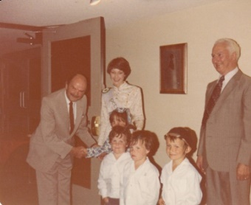
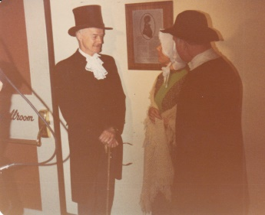
One event that stands out in my memory was a phone call from the manager of the Red Oak Inn. They were going to name their function room The Peter Robinson Ballroom. After a couple of phone calls, an interesting event was all underway. It was attended by our MPP. John Turner, Warden Jenkins, Mayor Cam Wasson an Executive and Board Members of the Club. The afternoon began with the arrival of Irish Settlers, well represented by the Moher and Crough families of all ages. It was a sight to see them walking along the banks of the river carrying farm equipment and cooking supplies. They were greeted by Peter Robinson portrayed by Doug Vasey and Adam Scott portrayed by Bill Jordan. The rest of the welcoming committee enjoyed the arrival as well. The plaque was unveiled by Shawn Mayne, Manager of the Irish Tourist Board for Canada and our 1980 Peterborough Rose, Jean McCarty, who represented the PCIC at the International Rose of Tralee Festival in Tralee County Kerry, Ireland.

(Top right picture Doug Vasey as Peter Robinson with Bill Jordan as Adam Scott)

( Above- Shawn Mayne,Jean McCarthy Rose of Tralee, Fred O’ Grady with children)

The Great Famine Monument 1847-1850 Del Crary Park

The PCIC has also erected a monument to the victims of what is known as The Great Famine 1847 to 1850. It was a terrible time in history that we must never allow to happen again. Many on the ships coming to Canada died at sea. Some as far as Grosse lle and the areas of Kingston, Peterborough and Toronto. This monument is located in the Del Crary Park on the pathway leading to the Marina which is located just where the fever sheds were located and where the entertainment stage is now.

The Plaque reads:

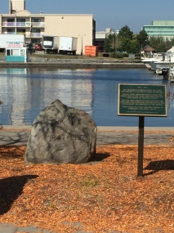
1847 – 1997- This monument commemorates the 150th anniversary of the Great Famine in Ireland. In 1847, many Irish emigrants fleeing the famine died in fever sheds near this site, then known as “Hospital Point”. Like the Irish emigrants who preceded and followed, the survivors contributed to the development and heritage of this region. Their legacy is a city and an area strong in community and family values.

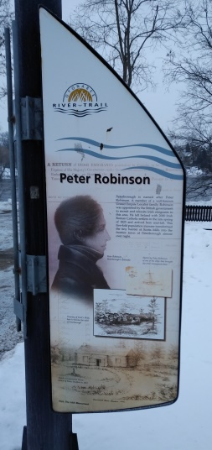
In 2000, through a fund raising effort with Brenda McGuinness-Leddy and Fred O’Grady we also added interpretive panels beside Settle’s Monument on the Millennium Walkway. Panel facing the street reads: Peter Robinson: Peterborough is named after Peter Robinson. A member of a well-known United Empire Loyalist. Robinson was appointed by the British government to recruit and relocate Irish emigrants to this area. He left Ireland with 2000 Irish Roman Catholic settlers in the late spring of 1825 and arrived her mid-fall. This five-fold population increased transformed the tiny hamlet of Scott Mills into the frontier town of Peterborough almost overnight. (Sketch of sailing ship. Drawing of Scott Mills. Sketch of Government House in 1832)

Panel facing the walkway and river reads: Irish Heritage: Following 1825 thousands of relatives and friends of the Robinson settlers and other Irish exiles left their beloved Emerald Isle for the rolling hills of the Peterborough Countryside.
They emigrated to escape overcrowding, poverty, political unrest, religious tensions, disease and Potato Famine. By 1851, almost half of the town of Peterborough`s population claimed Irish Ancestry.
They cleared land and these Irish families provided the basis for future generations to move into skilled trades, business and commerce, various professions, politics and government service.
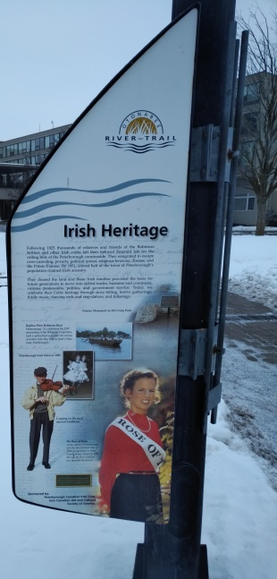
Today we celebrate the Celtic heritage through story –telling, festive gatherings, fiddle music, dancing reels, set-dances and folk songs. (Picture on Famine Monument in Del Cray Park, picture of replica Robinson Boat crossing Little Lake to re-enact settler arriving in 1975, Picture of Irish dancers in full costume, Picture of Kevin Leahy playing violin and picture of Laura Gainey the first Canadian to win the International Rose of Tralee title in Tralee, County Kerry, Ireland in 1882.

Any Club is only as strong as its membership. We have been fortunate to have many of the descendants of 1825 and 1847 and the families who followed them, still desiring to promote their heritage. We are a proud people and have set a good example for our children and grandchildren to follow.
Let us all enjoy the 45th birthday of the Peterborough Canadian Irish Club.

